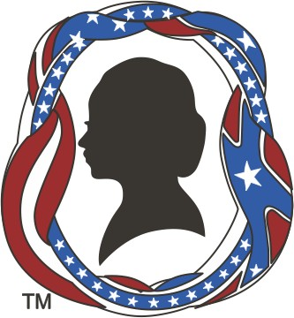
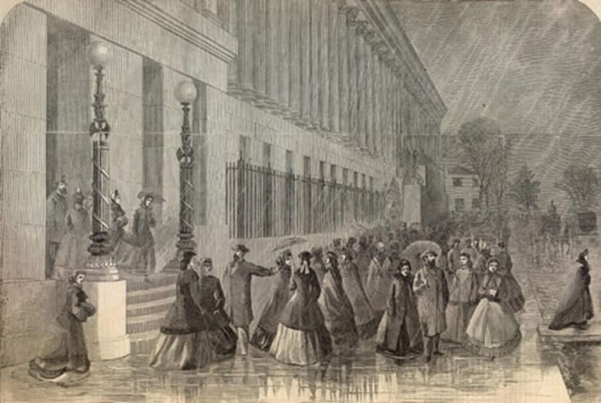
SWCW is dedicated to recognizing the lives and contributions of women who lived through, or participated in, the American Civil War. It also supports those who research, reenact, or otherwise honor these women of the past. The society sponsors an annual conference and two publications: the monthly “Calling Card,” providing announcements of events of interest, and “At Home and in the Field,” a quarterly e-journal.
The Society for Women and the Civil War
23rd Annual Conference
“Women in Government Service”
"Lady Clerks Leaving the Treasury Department at Washington"
(Courtesy of The American Civil War Center at Historic Tredegar)

July 27-30, 2023
Carlisle Pennsylvania
CONFERENCE
HOTEL LOCATION
Comfort Suites Hotel Downtown, Carlisle, PA
U.S. Army Heritage and Education Center (USAHEC)
Conference Partner:
Old Baldy Civil War Roundtable
Comfort Suites Downtown 10 South Hanover Street Carlisle, PA
(717) 960-1000
https://www.choicehotels.com/reservations/ groups/DI02L8
$139.00 per night + tax (xx.y%) All rooms are suites, single or double occupancy. Parking $5.20 per night.
A block of rooms at this special rate has been reserved. Reserve your room by phone or at: https://www.choicehotels.com/reservations/ groups/DI02L8
The rate may be extended to 3 days prior and 3 days after the conference. However, there are limited rooms available for these days.
To use our conference rate, please reserve your room by June 17, 2023.
Conference Registration
Website: www.swcw.org EMail contact swcw1865@gmail.com
or:
Society for Women and the Civil War
P.O. Box 3117
Gettysburg PA 17325
MEMBERS – FULL REGISTRATION - $ 325.00 NON-MEMBERS – FULL REGISTRATION –
$ 375.00
(PayPal or credit card accepted at registration website)

REGISTER BEFORE JULY 15, 2023
The U.S. Army Heritage and Education Center maintains the knowledge repositories that support scholarship and research about the
U.S. Army and its operating environment.

SATURDAY, JULY 29, 2023

Friday, JULY 28, 2023

SUNDAY, JULY 30, 2023
Breakfast at the Comfort Suites
Breakfast at the Comfort Suites

FRIDAY AFTERNOON
COMFORT SUITES HERITAGE ROOM
ARMY HERITAGE EDUCATION CENTER
The Best Known, Unknown Woman of the War Betsy Estilow speaks on Dorothea Dix, also known as "Dragon Dix." Has history been fair to her?
Dix's Influence on Nurses in the US Military Allison Millward tells us how Dorothea Dix influenced the modern nursing field.
Harriet Dame
Mike Pride will introduce us to Harriet Dame, a woman who served as a vivandiere with the 2nd N.H.
New Perspectives on Women Caregivers at
Gettysburg
Barbara Franco will help us see women caregivers at Gettysburg in a new light.
Check-In at Comfort Suites Downtown Carlisle
U.S. Army Heritage Education Center
Using the Resources of the Heritage Education Center
Members of the Center will instruct attendees on how to login and utilize the research facilities.
Unsung Heroines: Black Nurses of the Civil War
Jill Newmark addresses this little known topic on Black women in the Civil War.

Shippensburg Fashion Archive -Civil War Dresses
Presentation by Dr. Karin J. Bohleke, Ph.D. on the Civil War dresses held by the Fashion Archive.

SWCW Annual Meeting and Reception -
FRIDAY NIGHT
Hearty Hors d'oeuvres
Officers and committee chairs report accomplish
ments
or t
in our organization’s programs and on planning f future.
Keynote Speaker
Stephen Romaine will present
"Richmond Spies"
Stephen Romaine will educate us on the numerous spies that were at work in Richmond during the war.

ARMY HERITAGE TRAIL & MUSEUM
Take a stroll through the Heritage Center's Heritage Trail and interact with the reenactors who will teach us about life in an authentic Civil War camp as well as more modern Army camps.
FOR FASTER
REGISTRATION, SCAN THE CODE BELOW:
Role of Women in US Army General Hospital at York, PA
Scott L. Mingus, Sr. will inform us about the role of
women in US Army General Hospitals specifically in York, PCAo.
BANQUET & AUCTION
We’ll enjoy a fabulous dinner of delicious offerings provided by the chefs of the hotel's award winning restaurant, 1794 The Whiskey Rebellion.
Twilight Madness
Auction, Sales Tables, and Information Sharing Bring donations for the auction when you check-in on Friday. Bid on donated treasures, with auction proceeds going to the Scholarship Fund. Talk with authors and buy their books. Share information on SWCW programs, on local events, and on places to visit related to women and the Civil War.

Hospitality Suite
On both Friday and Saturday nights, join us at our Hospitality Suite in the hotel for complimentary evening snacks, libations, fellowship and networking.

